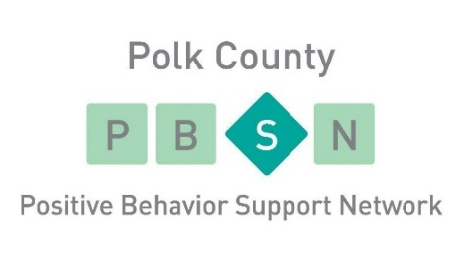
FY 22/23 Annual Report

The Polk County PBS Network is a multi-agency collaboration among Candeo, ChildServe, Community Support Advocates, Crest Services, Easterseals Iowa, Eyerly Ball, Goodwill of Central Iowa, Hope, Link Associates, ISA/FACT Agencies, Lutheran Services in Iowa, Mainstream Living, Mosaic, Optimae Life Services, Polk County BHDS, Polk County Integrated Services, and Progress Industries.

FY22/23 Progress on Strategic Plan Goals

General Summary of FY22/23 Board Activity
The PBSN Board worked this year to learn the tools needed to implement the new strategic plan. This included working through several objectives and creating a timeline for the steps needed to complete the first objectives. The new plan serves as a working document that continues to evolve and guide the board in our Mission and Vision.
Along with the work on our Strategic plan, we continued to have success with the following:
- Academy- continued to provide trainings in-person and virtually. The Academy was a great support to the Agencies, Staff, and Persons Served.
- 19 people have completed Front Line Supervisor (FLS) training
- Quarterly meetings- These meetings continued to provide support, discussion, and a chance to network with others. Topics in the quarterlies covered new items like C3 training and Success in the Workplace. Expand on new format of sharing the tools after the training. Focused on a book and did and provided training around it as a resource.
- Collaboration between agencies continued with sharing of trainings such as C3 and Motivational Interviewing. This continued to grow
- Returned to in person SIM training
- C3 training this year

SPECIAL THANKS:
The PBS Network has maintained a huge amount of resiliency and has been able to continue our mission to promote innovative, positive supports for persons served through inter-agency collaboration.

We could not have made the successes of this past year possible without our strong network of members and would like to thank our member organizations who have continued to support our mission and PBS values, even during unprecedented challenges.

Thank you to our member agency CEOs and Executive Directors who continue to support our mission by sustaining their agency memberships and providing an environment that helps their staff attend the trainings and membership meetings sponsored by the Polk County PBS Network.

Thank you to our Board members for sharing their time and talents to strengthen our network by creating amazing quarterly membership meetings and continuing to further our mission by working together to develop a new Strategic Plan that will help strengthen our network.

Thank you to our Front-Line Supervisor Training Cohort for your dedication and hard work in supporting the Front-Line Supervisor training, and flexibility in changing training formats to meet the health and safety needs of the community.

Thank you to our Training Academy members for working tirelessly throughout the year to bring our member agencies quality training opportunities and demonstrating a high level of ingenuity to offer these trainings on a platform that takes health and safety measures into consideration.

Thank you to Polk County BHDS for their continued financial and administrative support that enables the Polk County PBS Network to offer high value training such as Front-Line Supervisor training and networking benefits at an affordable price to our member agencies.

Thank you to Joe Benesh and The Ingenuity Company for providing the PBS board the supports and guidance needed with the development of a new Strategic Plan and the tools to implement it.

